

**UNIVERSITY INSTITUTE OF ENGINEERING**

**Department of Computer Science & Engineering**

**Subject Name:**  IOT Lab

**Submitted to: Submitted by:**

Er. Manni Kumar Name: Rahul Kumar

UID: 20BCS7081

Section: 716

Group: B

**INDEX**

|  |  |  |  |  |  |  |
| --- | --- | --- | --- | --- | --- | --- |
| **Ex. No** | **List of Experiments** | **Conduct (MM: 12)** | **Viva**  **(MM: 10)** | **Record (MM: 8)** | **Total**  **(MM: 30)** | **Remarks/Signature** |
| 1.1 |  |  |  |  |  |  |
| 1.2 | Types of sensor and how to use them |  |  |  |  |  |
| 1.3 |  |  |  |  |  |  |
| 2.1 |  |  |  |  |  |  |
| 2.2 |  |  |  |  |  |  |
| 2.3 |  |  |  |  |  |  |
| 2.4 |  |  |  |  |  |  |
| 3.1 |  |  |  |  |  |  |
| 3.2 |  |  |  |  |  |  |
| 3.3 |  |  |  |  |  |  |

**Experiment1.2**

**Student Name: Rahul Kumar UID: 20BCS7081**

**Branch: CSE Section/Group: 716/B**

**Semester: 6th Date of Performance: 27 Feb 2023**

**Subject Name: IOT Lab**

**Aim:**

Identification of different sensors used in IoT applications.

# Objectives:

1. To study hardware related to IoT.
2. To understand and identify different sensors used in IoT.

**Script And Output:**

# Sensors:

There are numerous definitions as to what a sensor is but I would like to define a Sensor as an input device which provides an output (signal) with respect to a specific physical quantity (input).

The term “input device” in the definition of a Sensor means that it is part of a bigger system which provides input to a main control system (like a Processor or a Microcontroller).

Another unique definition of a Sensor is as follows: It is a device that converts signals from one energy domain to electrical domain. The definition of the Sensor can be better understood if we take an example in to consideration.

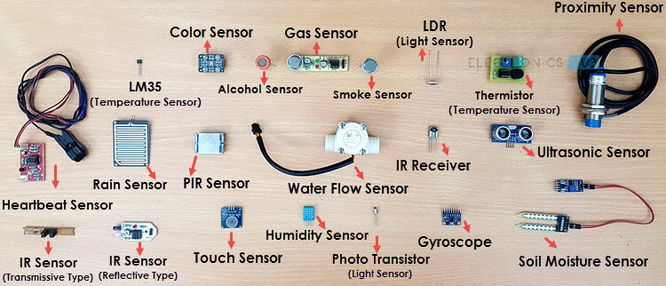

The simplest example of a sensor is an LDR or a Light Dependent Resistor. It is a device, whose resistance varies according to intensity of light it is subjected to. When the light falling on an LDR is more, its resistance becomes very less and when the light is less, well, the resistance of the LDR becomes very high.

We can connect this LDR in a voltage divider (along with other resistor) and check the voltage drop across the LDR. This voltage can be calibrated to the amount of light falling on the LDR. Hence, a Light Sensor.Now that we have seen what a sensor is, we will proceed further with the classification of Sensors.

## **Classification of Sensors:**

There are several classifications of sensors made by different authors and experts. Some are very simple and some are very complex. The following classification of sensors may already be used by an expert in the subject but this is a very simple classification of sensors.

In the first classification of the sensors, they are divided in to Active and Passive. Active Sensors are those which require an external excitation signal or a power signal.

Passive Sensors, on the other hand, do not require any external power signal and directly generates output response.

The other type of classification is based on the means of detection used in the sensor. Some of the means of detection are Electric, Biological, Chemical, Radioactive etc.

The next classification is based on conversion phenomenon i.e., the input and the output. Some of the common conversion phenomena are Photoelectric, Thermoelectric, Electrochemical, Electromagnetic, Thermooptic, etc.

The final classification of the sensors are [Analog and Digital](https://www.electronicshub.org/analog-circuits-and-digital-circuits/) Sensors. Analog Sensors produce an analog output i.e., a continuous output signal (usually voltage but sometimes other quantities like Resistance etc.) with respect to the quantity being measured.

Digital Sensors, in contrast to Analog Sensors, work with discrete or digital data. The data in digital sensors, which is used for conversion and transmission, is digital in nature.

## **Different Types of Sensors:**

The following is a list of different types of sensors that are commonly used in various applications. All these sensors are used for measuring one of the physical properties like Temperature, Resistance, Capacitance, Conduction, Heat Transfer etc.

1. Temperature Sensor
2. Proximity Sensor
3. Accelerometer
4. IR Sensor (Infrared Sensor)
5. Pressure Sensor
6. Light Sensor
7. Ultrasonic Sensor
8. Smoke, Gas and Alcohol Sensor
9. Touch Sensor
10. Color Sensor
11. Humidity Sensor
12. Position Sensor
13. Magnetic Sensor (Hall Effect Sensor)
14. Microphone (Sound Sensor)
15. Tilt Sensor
16. Flow and Level Sensor
17. PIR Sensor
18. Touch Sensor
19. Strain and Weight Sensor

.

### **Temperature Sensor:**

One of the most common and most popular sensors is the Temperature Sensor. A Temperature Sensor, as the name suggests, senses the temperature i.e., it measures the changes in the temperature.

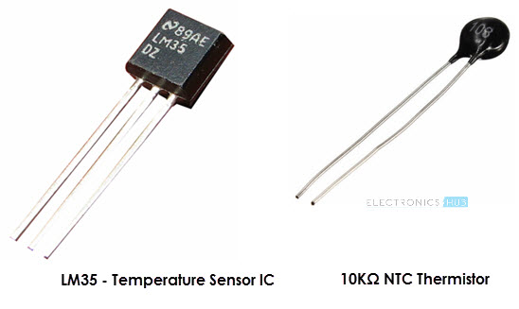

There are different types of Temperature Sensors like Temperature Sensor ICs (like LM35, DS18B20), Thermistors, Thermocouples, RTD (Resistive Temperature Devices), etc.

Temperature Sensors can be analog or digital. In an Analog Temperature Sensor, the changes in the Temperature correspond to change in its physical property like resistance or voltage. LM35 is a classic Analog Temperature Sensor.

Coming to the Digital Temperature Sensor, the output is a discrete digital value (usually, some numerical data after converting analog value to digital value).

Temperature Sensors are used everywhere like computers, mobile phones, automobiles, air conditioning systems, industries etc.

A simple project using LM35 (Celsius Scale Temperature Sensor) is implemented in this project.

### **Proximity Sensors:**

A Proximity Sensor is a non-contact type sensor that detects the presence of an object. Proximity Sensors can be implemented using different techniques like Optical (like Infrared or Laser), Sound (Ultrasonic), Magnetic (Hall Effect), Capacitive, etc.

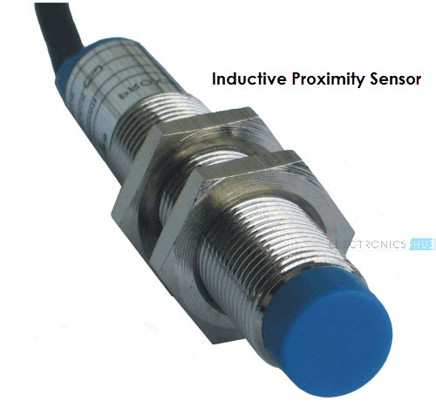

Some of the applications of Proximity Sensors are Mobile Phones, Cars (Parking Sensors), industries (object alignment), Ground Proximity in Aircrafts, etc.

Proximity Sensor in Reverse Parking is implemented in this Project.

### **Infrared Sensor (IR Sensor):**

IR Sensors or Infrared Sensor are light based sensor that are used in various applications like Proximity and Object Detection. IR Sensors are used as proximity sensors in almost all mobile phones.

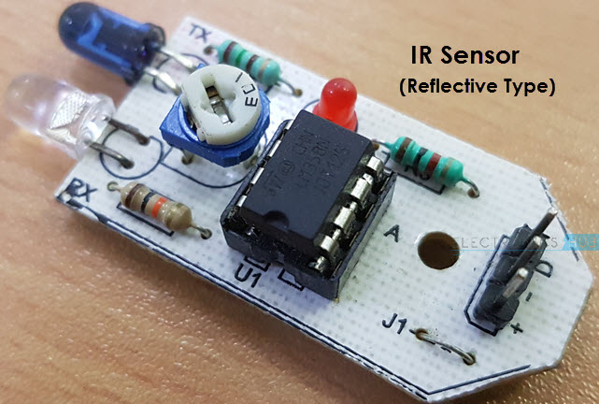

There are two types of Infrared or IR Sensors: Transmissive Type and Reflective Type. In Transmissive Type IR Sensor, the IR Transmitter (usually an IR LED) and the IR Detector (usually a Photo Diode) are positioned facing each other so that when an object passes between them, the sensor detects the object.

The other type of IR Sensor is a Reflective Type IR Sensor. In this, the transmitter and the detector are positioned adjacent to each other facing the object. When an object comes in front of the sensor, the infrared light from the IR Transmitter is reflected from the object and is detected by the IR Receiver and thus the sensor detects the object.

Different applications where IR Sensor is implemented are Mobile Phones, Robots, Industrial assembly, automobiles etc.

A small project, where IR Sensors are used to turn on street lights.

### **Ultrasonic Sensor:**

An Ultrasonic Sensor is a non-contact type device that can be used to measure distance as well as velocity of an object. An Ultrasonic Sensor works based on the properties of the sound waves with frequency greater than that of the human audible range.

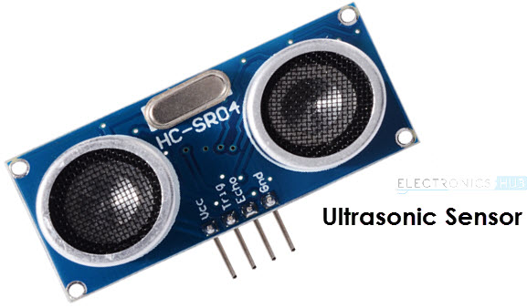

Using the time of flight of the sound wave, an Ultrasonic Sensor can measure the distance of the object (similar to SONAR). The Doppler Shift property of the sound wave is used to measure the velocity of an object.

Arduino based Range Finder is a simple project using Ultrasonic Sensor.

### **Light Sensor:**

Sometimes also known as Photo Sensors, Light Sensors are one of the important sensors. A simple Light Sensor available today is the Light Dependent Resistor or LDR. The property of LDR is that its resistance is inversely proportional to the intensity of the ambient light i.e., when the intensity of light increases, its resistance decreases and vise-versa.

By using LDR is a circuit, we can calibrate the changes in its resistance to measure the intensity of Light. There are two other Light Sensors (or Photo Sensors) which are often used in complex electronic system design. They are Photo Diode and [Photo Transistor](https://www.electronicshub.org/basics-of-phototransistor/). All these are Analog Sensors.

[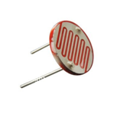](https://www.electronicshub.org/wp-content/uploads/2015/01/LDR-Photoresistor.png)

There are also Digital Light Sensors like BH1750, TSL2561, etc., which can calculate intensity of light and provide a digital equivalent value.

### **Smoke and Gas Sensors:**

One of the very useful sensors in safety related applications are Smoke and Gas Sensors. Almost all offices and industries are equipped with several smoke detectors, which detect any smoke (due to fire) and sound an alarm.

Gas Sensors are more common in laboratories, large scale kitchens and industries. They can detect different gases like LPG, Propane, Butane, Methane (CH4), etc.

[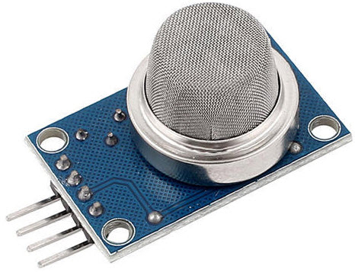](https://www.electronicshub.org/wp-content/uploads/2017/11/Smoke-Sensor-MQ2.jpg)

Now-a-days, smoke sensors (which often can detect smoke as well gas) are also installed in most homes as a safety measure.

The “MQ” series of sensors are a bunch of cheap sensors for detecting CO, CO2, CH4, Alcohol, Propane, Butane, LPG etc. You can use these sensors to build your own Smoke Sensor Application.

### **Alcohol Sensor:**

As the name suggests, an Alcohol Sensor detects alcohol. Usually, alcohol sensors are used in breathalyzer devices, which determine whether a person is drunk or not. Law enforcement personnel uses breathalyzers to catch drunk-and-drive culprits.

[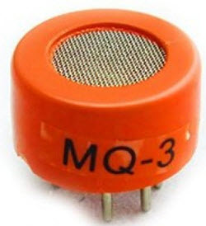](https://www.electronicshub.org/wp-content/uploads/2017/11/Alcohol-Sensor-MQ3.jpg)

### **Touch Sensor:**

We do not give much importance to touch sensors but they became an integral part of our life. Whether you know or not, all touch screen devices (Mobile Phones, Tablets, Laptops, etc.) have touch sensors in them. Another common application of touch sensor is trackpads in our laptops.

Touch Sensors, as the name suggests, detect touch of a finger or a stylus. Often touch sensors are classified into Resistive and Capacitive type. Almost all modern touch sensors are of Capacitive Types as they are more accurate and have better signal to noise ratio.

[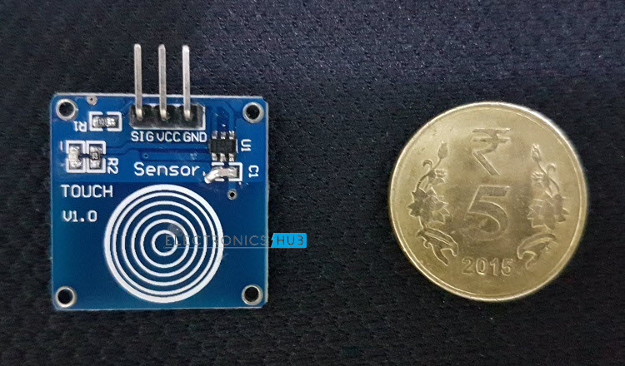](https://www.electronicshub.org/wp-content/uploads/2017/03/Touch-Sensor-Module.jpg)

If you want to build an application with Touch Sensor, then there are low-cost modules available and using those touch sensors.

### **Color Sensor:**

A Color Sensor is an useful device in building color sensing applications in the field of image processing, color identification, industrial object tracking etc. The TCS3200 is a simple Color Sensor, which can detect any color and output a square wave proportional to the wavelength of the detected color.

[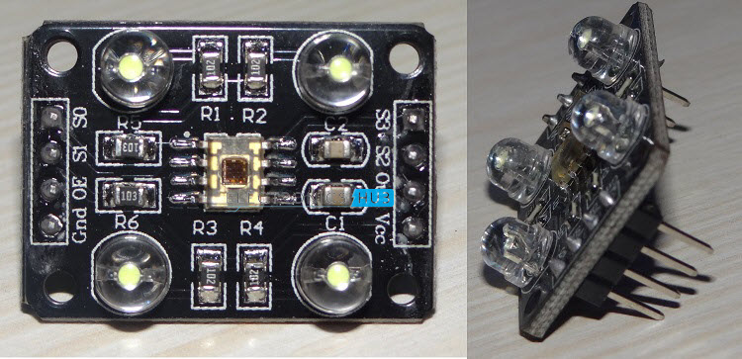](https://www.electronicshub.org/wp-content/uploads/2017/04/TCS3200-Color-Sensor.jpg)

If you are interested in building a Color Sensor Application.

### **Humidity Sensor:**

If you see Weather Monitoring Systems, they often provide temperature as well as humidity data. So, measuring humidity is an important task in many applications and Humidity Sensors help us in achieving this.

Often all humidity sensors measure relative humidity (a ratio of water content in air to maximum potential of air to hold water). Since relative humidity is dependent on temperature of air, almost all Humidity Sensors can also measure Temperature.

[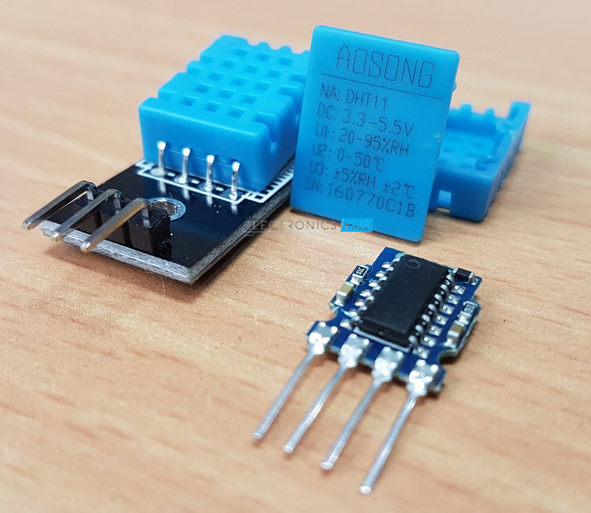](https://www.electronicshub.org/wp-content/uploads/2017/06/DHT11-Sensor.jpg)

Humidity Sensors are classified into Capacitive Type, Resistive Type and Thermal Conductive Type. DHT11 and DHT22 are two of the frequently used Humidity Sensors in DIY Community (the former is a resistive type while the latter is capacitive type).

### **Tilt Sensor:**

Often used to detect inclination or orientation, Tilt Sensors are one of the simplest and inexpensive sensors out there. Previously, tilt sensors are made up of Mercury (and hence they are sometimes called as Mercury Switches) but most modern tilt sensors contain a roller ball.

[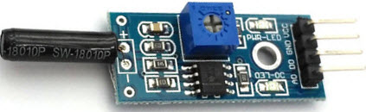](https://www.electronicshub.org/wp-content/uploads/2021/01/Tilt-Sensor-Module.jpg)